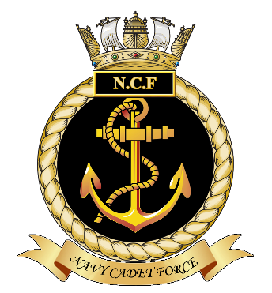
NCF AF 6

April 2015
NAVY CADET FORCE

PHOTOGRAPHIC PARENTAL CONSENT FORM

Unit Name
Name of Cadet

From time to time the N.C.F may take, or allow others to take, photographs and film footage of cadets at their unit or whilst taking part in activities, camps or events in order to help promote our organisation. These photographs and images may appear in the press, on social networking sites, in printed publications, promotional material, on television or on a website.

Before photographs of your child are taken, your permission is needed. Please answer either YES or NO in the boxes opposite the questions below and sign and date the form where shown.

1. | May the N.C.F use your child’s photograph or images in its publicity material?
2 | May the N.C.F allow your child’s photograph to appear in the media?
3. | May the N.C.F take and use a photograph of your child for an individual identity card and retain a copy on the Cadet’s file?

Conditions of use:

- This consent will remain valid for the full period of your child’s attendance as a member of the Navy Cadet Force.

- Parents or Guardians may withdraw the consent at any time in writing to the Commanding Officer of the Unit.

- We will not include, or release to the media any address details or telephone numbers to accompany photographs.

- Only photographs and images of Cadets who are suitably dressed will be taken or used.

- Names of Cadets will only be used where individual recognition is appropriate (e.g. newspaper coverage of annual awards evenings).

I have read and understood the conditions of use for my child’s photographs.
Parent’s/ Guardian’s Signature | Name (In block capitals) | Date

